**Winter Show Application Form**

Please **email your application with one associated photograph** to [artsinfo@richmondandwandsworth.gov.uk](mailto:artsinfo@richmondandwandsworth.gov.uk) **by 16 October at 12noon**. Please see The Opportunity and FAQs section for more information.

**It is vital that you type “#DOC” and your name (e.g. “#DOC Joe Bloggs”)** **into the subject line of each email.** There is a 30Mb max attachment size for each email. If the attachments size exceeds this, the email will not be delivered, and the application will not be received.

**Only artists living or working in the London Borough of Richmond Upon Thames are eligible to apply.**

**About you**

|  |  |
| --- | --- |
| Name |  |
| Where do you practice / create in the borough? |  |
| Please provide the address of where you practice / create in the borough |  |
| Email |  |
| Phone Number |  |
| Where did you find out about the opportunity? |  |
| Please complete our Equal Opportunities Monitoring Form | <https://forms.office.com/e/qkUwG0Wkca> |

**Artwork**

*The information provided below will be used for interpretation and marketing if the artwork is selected for the exhibition.*

|  |  |
| --- | --- |
| **Title** |  |
| **Medium**  (Materials used) |  |
| **Date**  (When was the work produced) |  |
| **Price**  (This is the price the work will be sold at, including OHG commission & VAT – please see FAQs to calculate) |  |
| **Are you VAT registered?** |  |
| **Is your work 2D or 3D?** (Please see FAQs for fixing requirements) |  |
| **Dimensions HxW or HxWxD in cm**  (If framed this must be total size framed) |  |
| **Social media handle OR website**  (If selected this will appear with your work, please select *only one* and indicate whether it is a website, Facebook, Instagram or Twitter) |  |
| **Artwork label text**  (In first person, max 50 words. This will be displayed next to your work during the exhibition) |  |
| **Image** | Please attach 1 high-res image of your artwork to this application |

**The Opportunity**

This is an opportunity to have work exhibited as part of a group exhibition in the Stables Gallery. Submissions are welcome across visual and contemporary artforms, both 2D and 3D. Your submission may be artwork that you have already produced, or a new work in response to this call out.

Orleans House Gallery will curate the exhibition, selecting artworks to be included based on:

* artistic quality of the work
* relevance to our communities
* alignment with our values below

Collaborative – we work with people in innovative and inspiring ways, we invite artists, communities and individuals to create the public programme with us and help develop the Arts Service.

Socially engaged – we respond to the needs and wishes of local people, widen participation in the arts and connect people from different backgrounds, enabling them to have a say over issues that affect them, and promoting opportunity particularly for underrepresented groups.

Experimental – through the arts we test new ideas and approaches and share our learning to support the work of the borough. This might involve being playful, adventurous and taking risks.

Enterprising – we will always be open to new ways of working, sustain and develop productive partnerships and seek to find ways to make our work financially sustainable and develop inward investment for the arts.

We particularly welcome submissions by artists from communities that are currently underrepresented at Orleans House Gallery.

**Orleans House Gallery will**

* Provide the exhibition space and organise an opening event
* Curate and install the exhibition
* Process art sales
* Publicise and promote the exhibition
* Provide invigilation of the exhibition

**How to apply**

**The deadline for proposals is 12 noon on Monday 16 October.**

Applicants can submit 1 piece of work to be reviewed by the selection committee. Please note we expect a high volume of applications and not all submissions will be selected or exhibited.

The work submitted, if selected, must be the work brought to the exhibition, i.e. you can’t make something different retrospectively.

If you have any queries, please email Arts Info [artsinfo@richmondandwandsworth.gov.uk](mailto:artsinfo@richmondandwandsworth.gov.uk) or call 020 8831 6000

**Frequently Asked Questions (FAQs)**

**What file-format should media be sent in?**

Please send images in either JPEG, PNG or BMP file formats. Please note that the attachment size limit is 30Mb.

**When do I find out if any of my work has been chosen?**

Applicants will be notified by email from week beginning 1 November 2023

**How much commission does the Orleans House Gallery take on exhibition sales?**

Orleans House Gallery receives 40% commission on all sales of original art and must also charge VAT on our commission rate; the two tables below show the structure of pricing for a Non-VAT registered exhibitor’s work and for a VAT registered exhibitor’s work:

|  |  |  |
| --- | --- | --- |
|  | **COMMISSION** | **VAT (Rate at 20%)** |
| **Non-VAT** | 40% of exhibitor’s price | 20% of commission |
| **VAT Registered** | 40% of exhibitor’s price | 20% of commission and exhibitor’s price |

Thus, if the exhibitor’s price is £100, below demonstrates the calculations required to work out the total selling price, please include the total selling price for your artwork in the application form above:

|  |  |  |  |
| --- | --- | --- | --- |
|  | **COMMISSION** | **VAT (Rate at 20%)** | **TOTAL** |
| **Non-VAT** | £40 | £40 x 20% = £8 | £100+£40+£8=**£148** |
| **VAT Registered** | £40 | (£40+£100) x 20%=£28 | £100+£40+£28=**£168** |

**If my work is chosen, will I be able to also sell a print run or postcards in the gallery shop?**

Unfortunately, you will only be able to sell the artwork itself, as there isn’t capacity to be able to process additional sales.

**Can I submit numerous works as one piece (i.e diptych/triptych)?**

Yes, however numerous works exhibited as one piece must be sold as such.

**Can I submit work requiring a power supply?**

Yes, however any items requiring mains power will need to be PAT tested privately (if selected), and a certificate of completion delivered to the gallery when artwork is dropped off.

**Can I sell work with the option to sell framed or unframed?**

Works that are presented in a frame must be sold as such.

**Is there a size limit?**

No. However, as this is a group exhibition, offering a chance for many individuals to contribute is important to us. The dimensions of the Stables Gallery are shown below to show the physical limitations of the space. Please consider door width for large exhibits.

**Will my work be insured by Orleans House Gallery?**

The works will not be insured by Orleans House Gallery. The Stables Gallery is invigilated throughout opening hours, but artwork is displayed at the artist’s own risk. For this reason, we recommend secure attachments such as mirror plates and providing secure casing or display. We also recommend arranging your own insurance for your artwork to cover any loses, damage or theft etc.

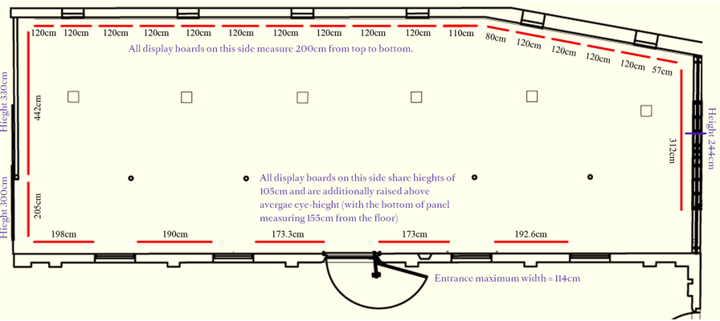

**Does 2D work need to come ready to hang e.g. with mirror plates / string attached?**

Yes, adequate fixings must be attached to your work. There are many acceptable hanging systems suitable for supporting works of art for long periods of time. Some examples of these are listed below.

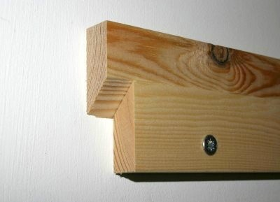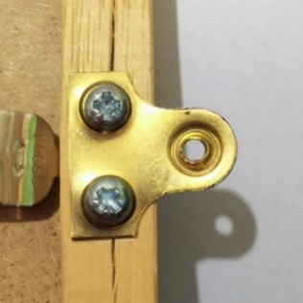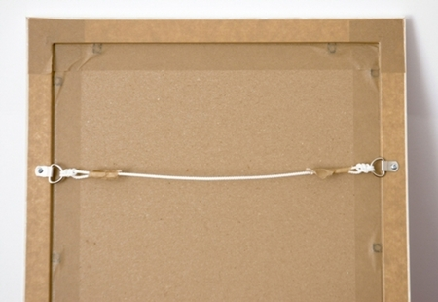Mirror/picture plates String/wire (D-rings) Split batten

**What about 3D work?**

3d work must arrive stable, ready to be placed on a surface or with its own secure display method.

**I have seen the Christmas Shopping Weekend advertised, is this the same as the Winter Show.**

Please note that on Friday 1 (evening), Saturday 2 & Sunday 3 December the annual *Christmas Shopping Weekend* at Orleans House Gallery will take place, with over 50 independent makers, sellers and artisans animating the site, including the Stables Gallery. There will be up to 12 artist pitches in the Stables Gallery across the weekend and your application to participate in the *Winter Show* does not include a pitch at this event. If you are interested in applying to take part in the *Christmas Shopping Weekend* at Orleans House Gallery, you can find more information on our website. You are welcome to apply for both opportunities.

**Will there be an opening celebration?**

Yes! The *Winter Show* will launch with a special event on the evening of Friday 1 December. The event will also mark the opening of the hugely popular annual *Christmas Shopping Weekend* at Orleans House Gallery. Visitors will be offered an exclusive first look at the works on display, alongside the opportunity to explore the Stables Gallery stalls of the artists participating in the *Christmas Shopping Weekend*. There will be (paid) refreshments and entertainment in the Stables Café which adjoins the gallery. The event will serve as the launch of our exciting winter season at Orleans House Gallery.